This document provides step-by-step instructions on printing and assembling the booklet using the Microsoft Word files. If you have other CD artwork printing software you prefer to use a complete set of “jpg” files are provided in the “PMG Comp Vol 1 JPG Files” folder

It will probably take you about 10 or 15 minutes to print & assemble the booklet.

Step #1 ~ Tools
In order to assemble the booklet you will need a pair of scissors and a stapler with a “jaw depth” of at least 3 inches (76 mm), see figure #1

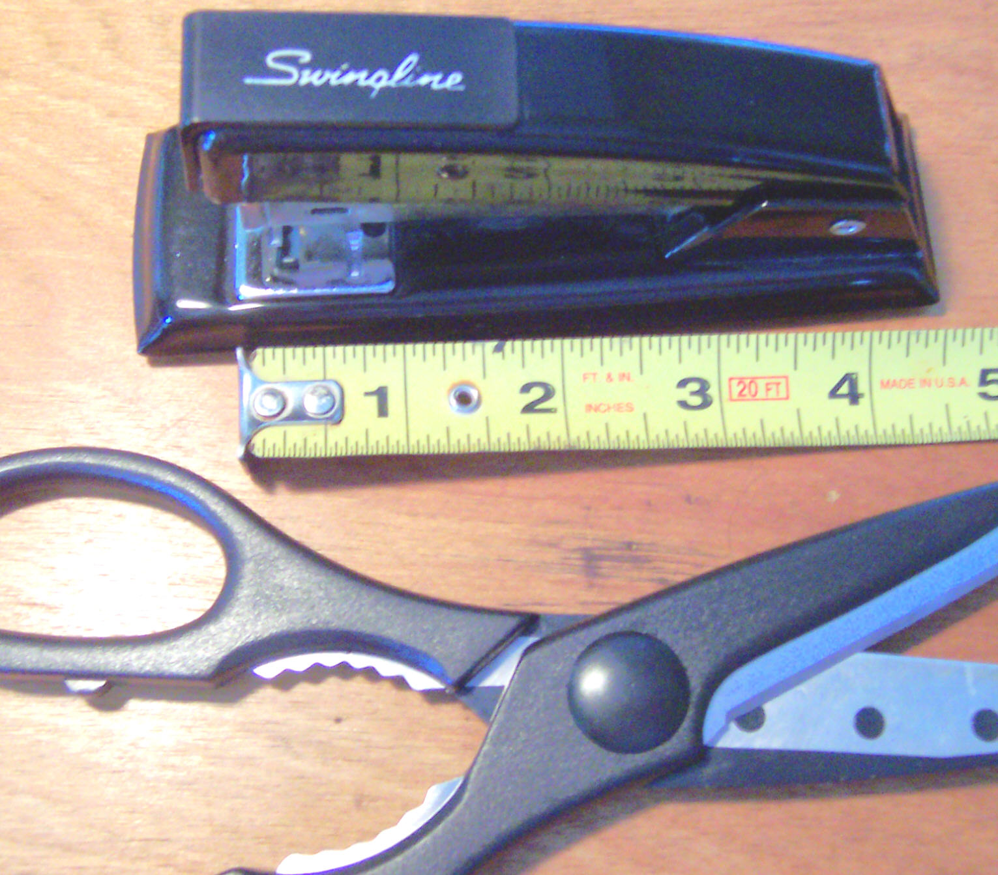
Jaw Depth
Figure #1

Step #2 ~ Open The Appropriate File For Your Paper Size
There are two Microsoft Word documents provided. One is entitled “PMG Comp Vol 1 Book.doc” this is formatted for standard letter sized (i.e., 8.5” x 11”) paper that is commonly used in North America. The other file is entitled “PMG Comp Vol 1 Book A4.doc” this document is formatted for A4 size paper that is used in other regions (e.g., Europe). Open the appropriate file for the paper size you will be using.

Step #3 ~ Enable Two-Sided Printing
In order to assemble the booklet you’ll need to enable two-sided printing. Most printers have the ability to do this, even the cheaper models (which usually print out half of the document then prompt you to remove the finished sheets, rotate them 180º, and then place them in the supply tray). No worries, this is simpler than it sounds.

Since you will be printing on both sides of the paper it is important to get the sheets to feed into the printer consistently, so that the artwork on both sides of the page line up evenly. To aid in this process it is recommended that you remove the paper from the supply tray and tap the edges on a tabletop so that they are square. Insert the paper into the tray and ensure the paper guides are set properly.

Now that the file is opened go to the “File” pull down menu in Word and select “Print.” The Print dialog box should now open – click on the “Properties” button. The printer’s “Properties” dialog box should now open. Select the “Two-Sided Printing” option (note: you may have to click through the tabs to find this option). Once the “Two-Sided Printing” option is selected click the “OK” button. This should now take you back to the print dialog box. Click “OK” to start printing.

NOTE: If you do not have a two-sided print option please go to step #5

Step #4 ~ Paper Handling
If you have one of the more sophisticated printers that automatically print on both sides of the paper you can skip to step #6.

If your printer requires you to manually remove the paper it will print out three one-sided sheets and then a dialog box should appear instructing you on what to do next. In most cases it will instruct you to removed the finished sheets, rotate them 180º, and then place them in the supply tray. Please follow the instructions in the dialog box that appears on your screen.

Step #5 ~ Instructions For Two-Sided “Manual” Printing
If your system won’t allow you to print two-sided you will have to print each page individually in the following manner.

Go to the “File” pull down menu in Word and select “Print,” this will open the print dialog box. In the print dialog box there will be a section entitled “Page Range.” Select the “Page” button and type in “1” (for page 1). Then select “OK” Your printer should now print out page #1.

After the printing is complete remove the printed page, rotate it 180º, and then place it in the supply tray as shown in figure #2.
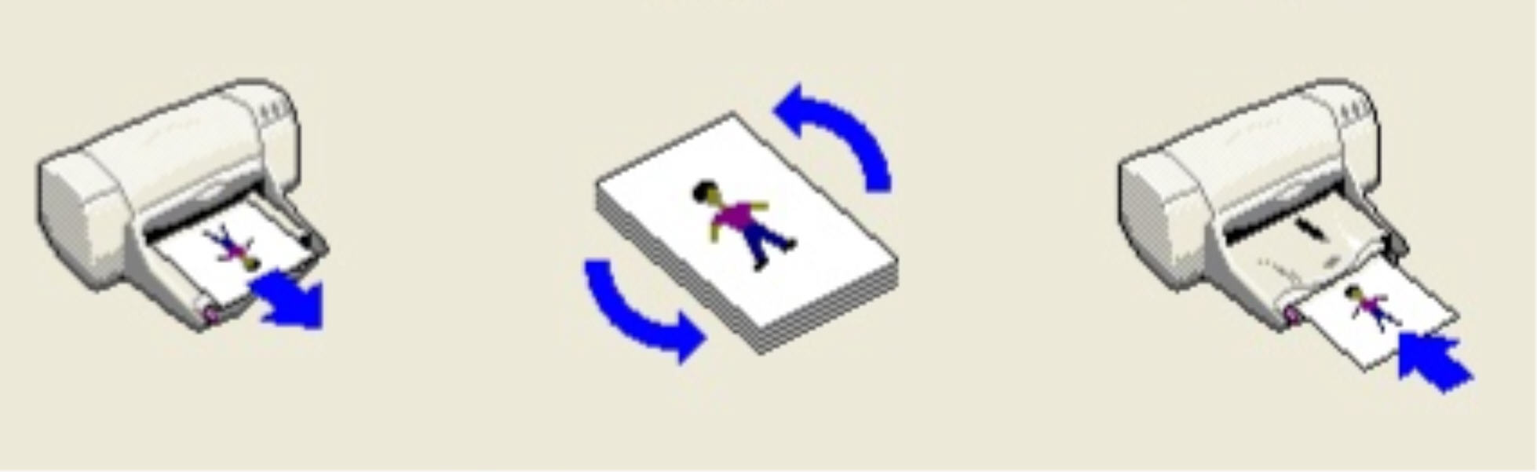
Figure #2

Again, go to the “File” pull down menu in Word and select “Print,” to open the print dialog box. In the print dialog box there will be a section entitled “Page Range.” Select the “Page” button and type in “2” (for page 1). Then select “OK” Your printer should now print out page #2 on the other side of page #1, thus producing a two-sided sheet.

Follow the steps above for the page 3 & 4 and page 5 & 6 pairings.

Step #6 ~ Cutting The Paper
Once the printing is complete you should have three two-sided sheets paired in the following matter:
- The first with the front & back cover of the booklet along with booklet pages 1 & 10
- The second with booklet pages 2 & 9 and 3 & 8
- The third with booklet pages 4 & 7 and 5 & 6

It is recommended that you hold the sheets up to a bright light to ensure that both sides are lined up properly. If they are not lined up it is most likely a result of your printer’s paper handling system.

Now carefully cut out the artwork. If the sides are not perfectly lined-up you may want to hold the sheets up against a bright light when you are cutting them to compensate for any misalignment, see figure #3.

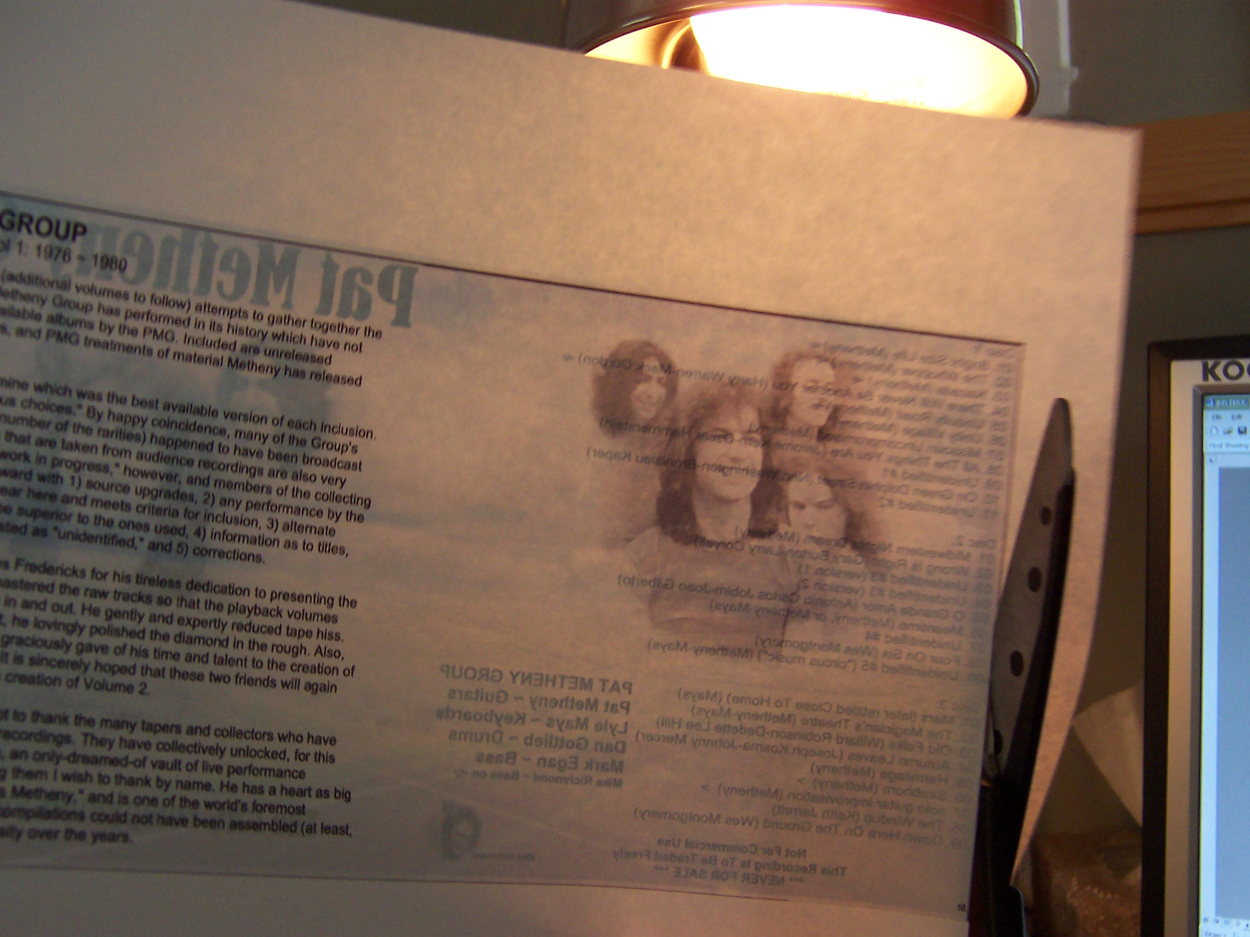
Figure #3

Step #7 ~ Folding
Carefully fold each individual sheet in half, ensure that the edges are aligned before applying a firm crease. It is recommended that you fold the each sheet in the opposite direction and then back again. This allows the “fold line” to be firmly established and should make the pages easier to turn once the final book is assembled.

Step #8 ~ Assembly
Assemble the three sheets. Page through the booklet to ensure that the pages are correctly assembled 1 through 10 (there are page numbers in the lower corners), make adjustments to fold direction or ordering as necessary.

Step #8 ~ Stapling
With all three folded sheets together, open the booklet to the center page (which should contain pages 5 & 6 of the text). Most staplers do not have a “jaw depth” deep enough to staple on the crease line. You can work around this by forming a “loop” with half of the booklet, see figure #4. When forming the loop ensure that the pages and their creases remain aligned. Be careful not fold the loop so that the page does not become creased.

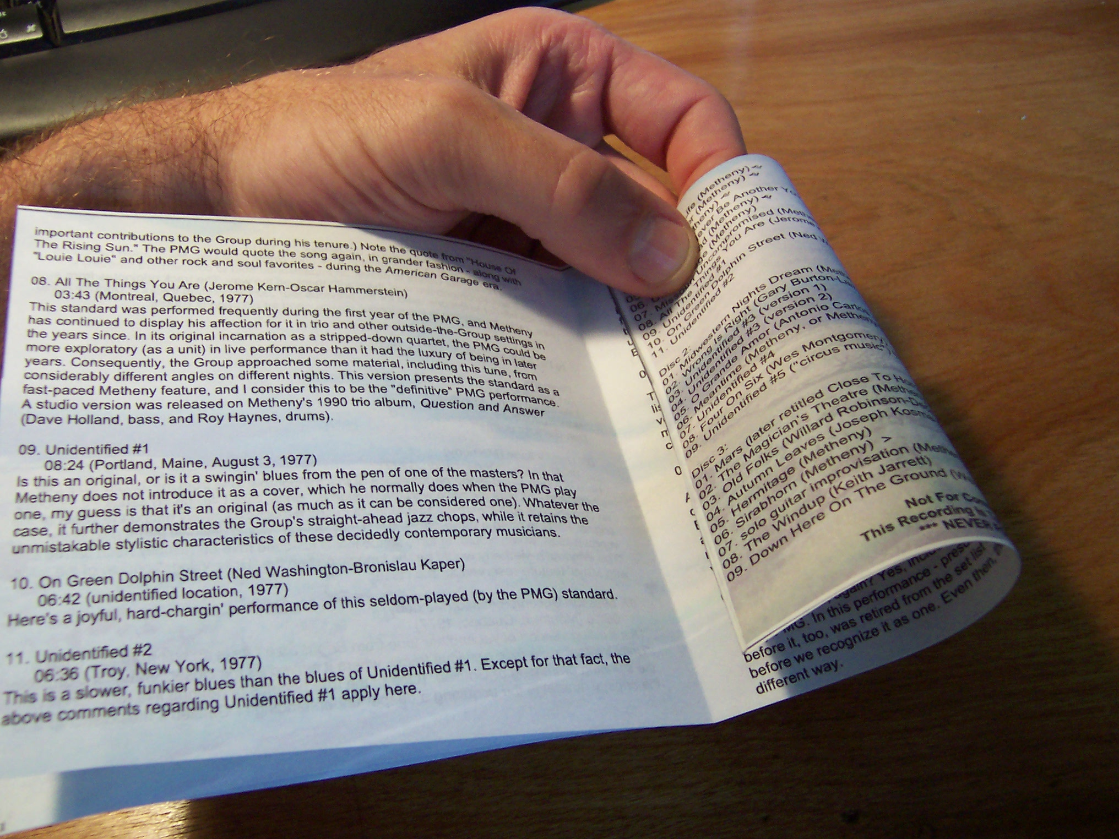
Loop
Crease
Figure #4

Side the loop into the stapler with the as shown in figure #5 (on next page). Make sure that the crease is lined up where the staple will be applied. You can ensure this alignment by putting the crease in the divots on the lower jaw of the stapler.

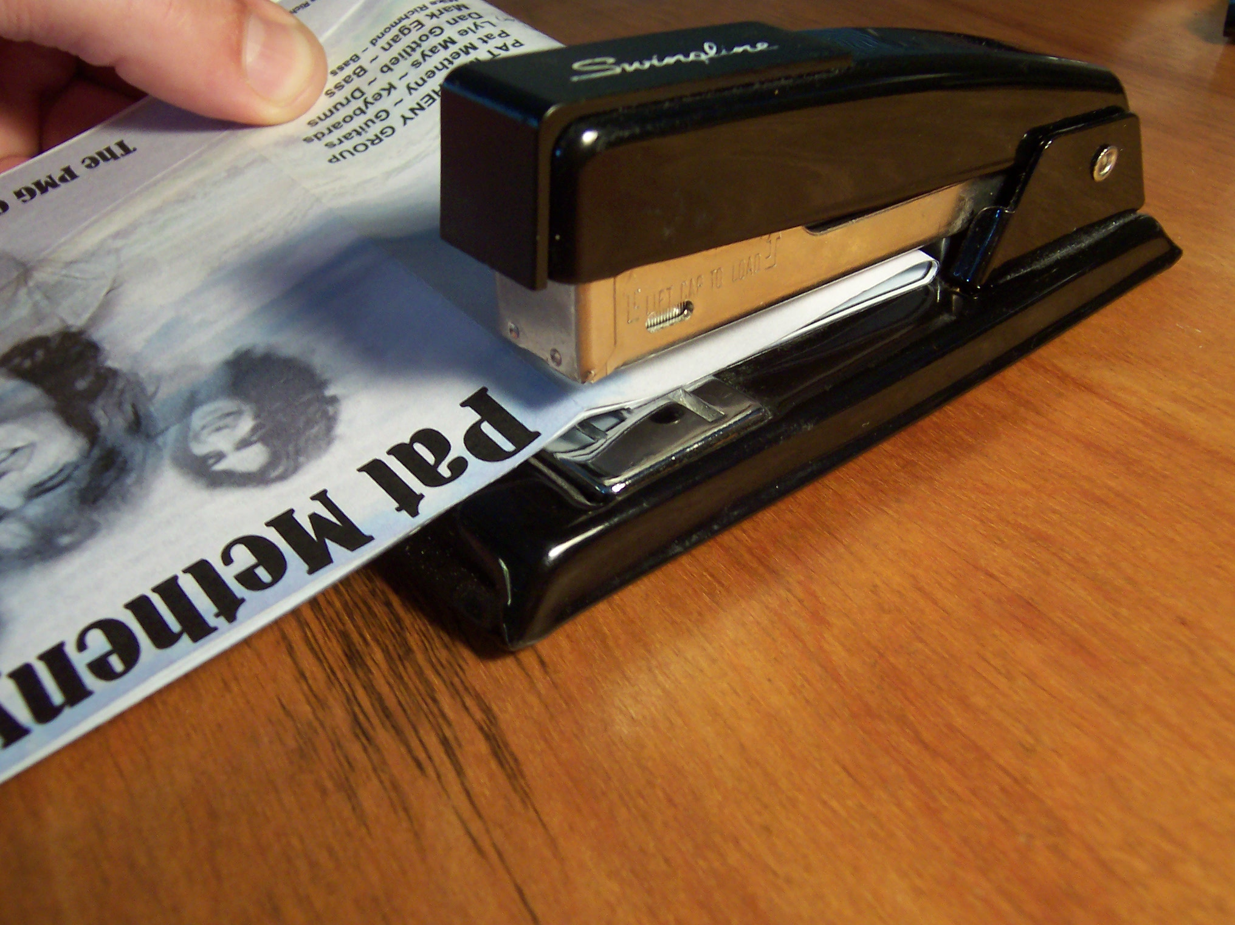
Line up crease with divots on lower jaw of stapler
Loop
Figure #5

Apply two staples while ensuring the crease is lined up as shown in figure #5.

With any luck, you should now have a booklet, figure #6.

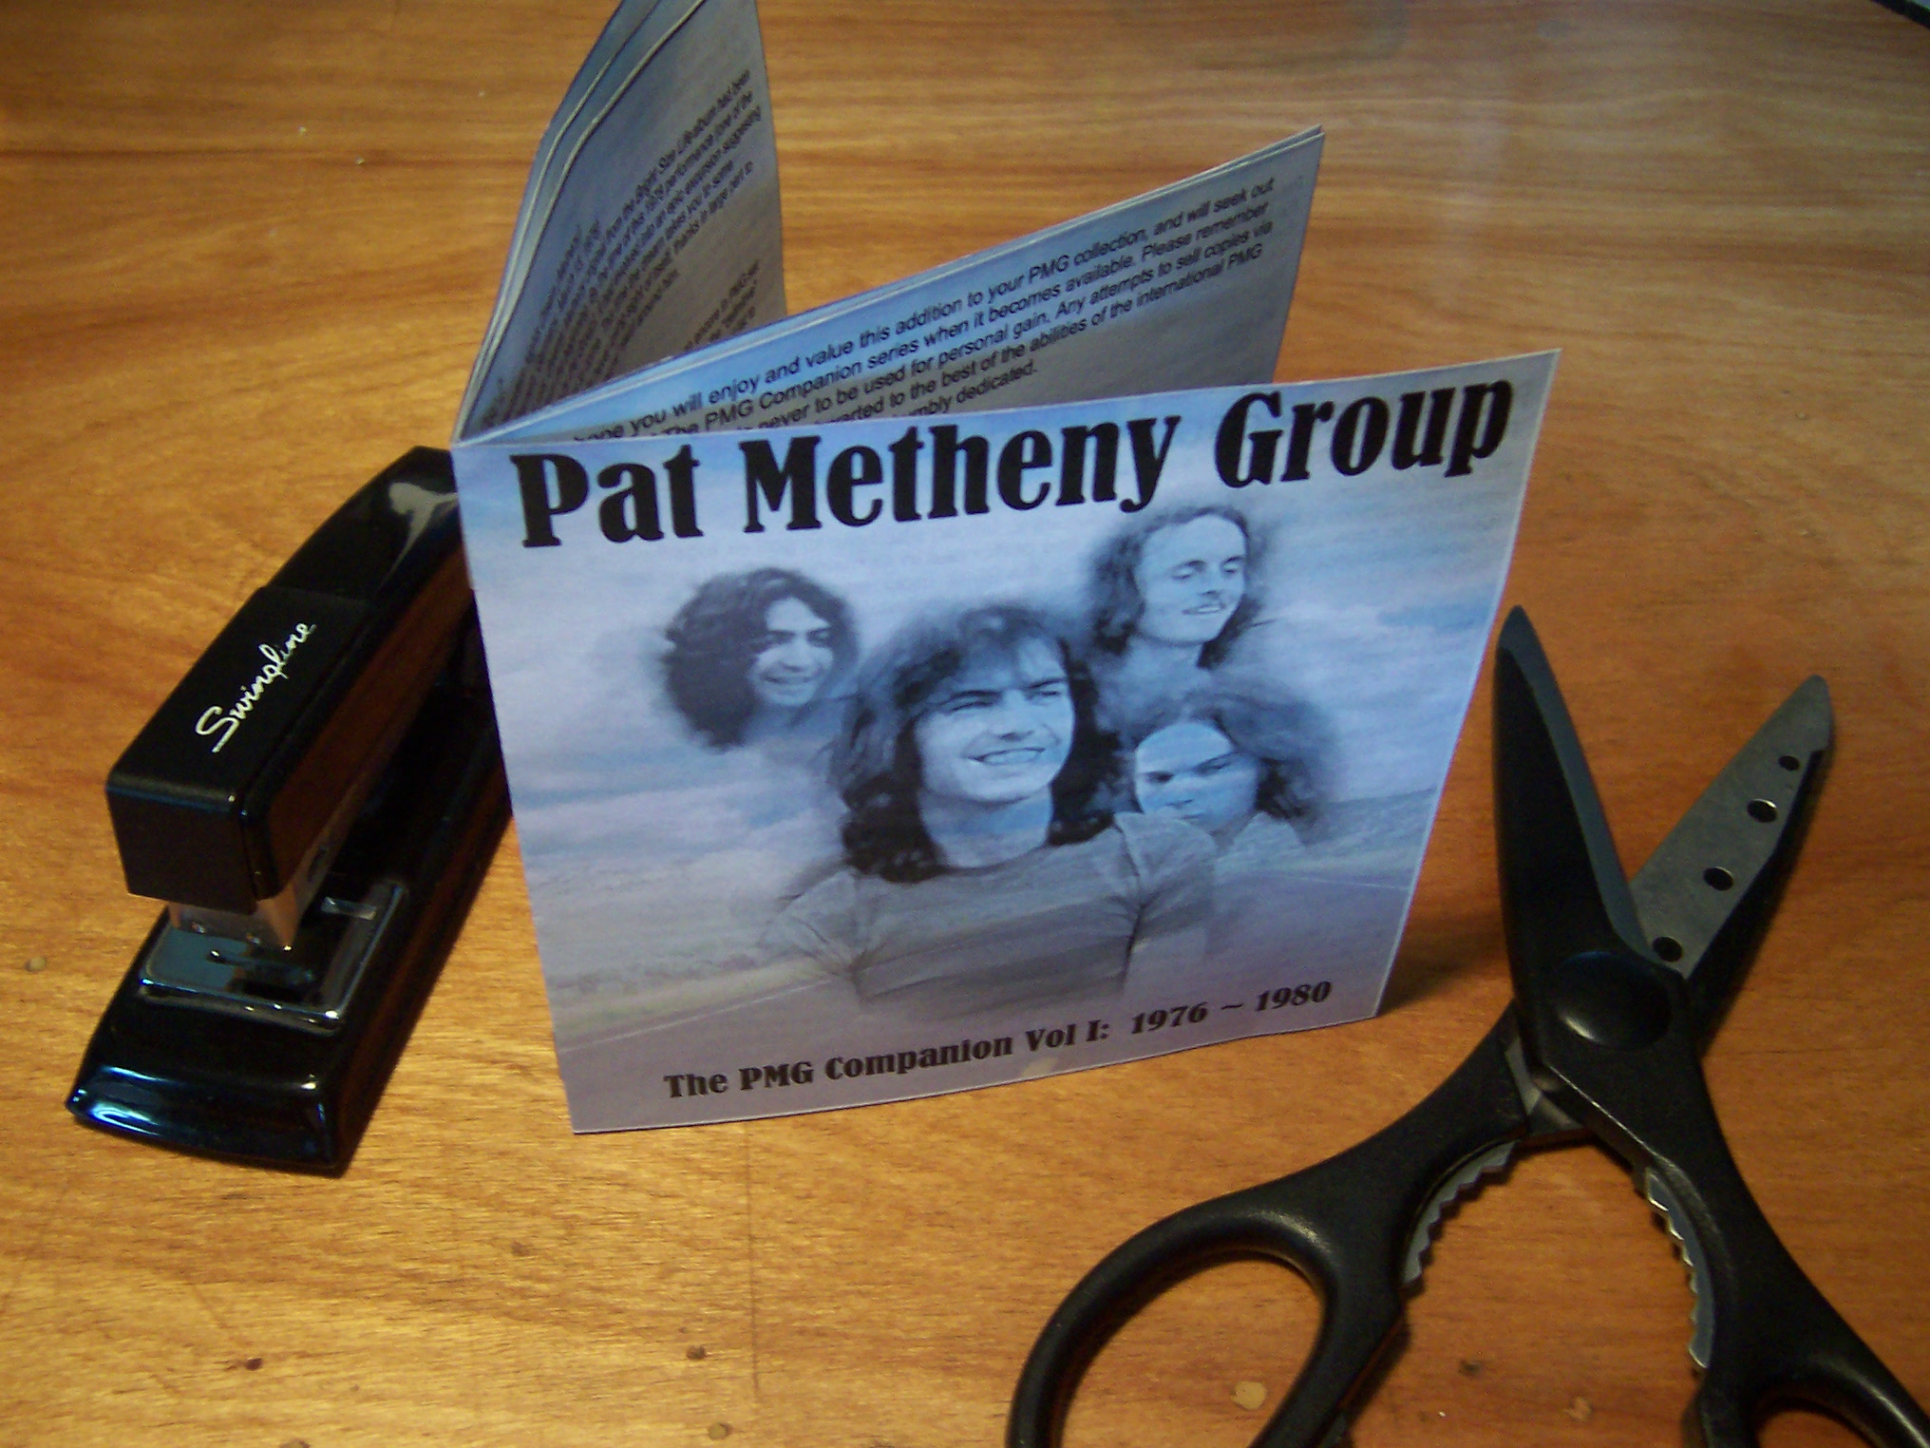
Figure #6

